Prepare Data by Amarah Iqbal.

**Get data from SQL Server**

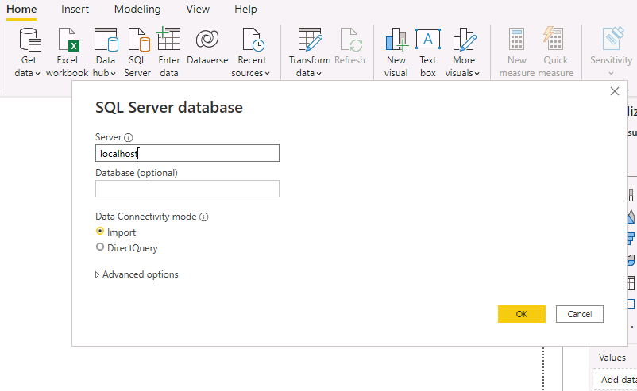

1. To create queries, select the checkbox selecting the requires tables

To apply transformations to the data of the selected tables, click **Transform Data**.

We will learn relevant information about the data like column quality, column distribution, and column profile tools to understand the data and to assess data quality.

To assess column quality, on the **View** ribbon tab, from inside the **Data Preview** group, check **Column Quality**.

The column quality feature allows to easily determine the percentage of valid, error, or empty values found in columns.

